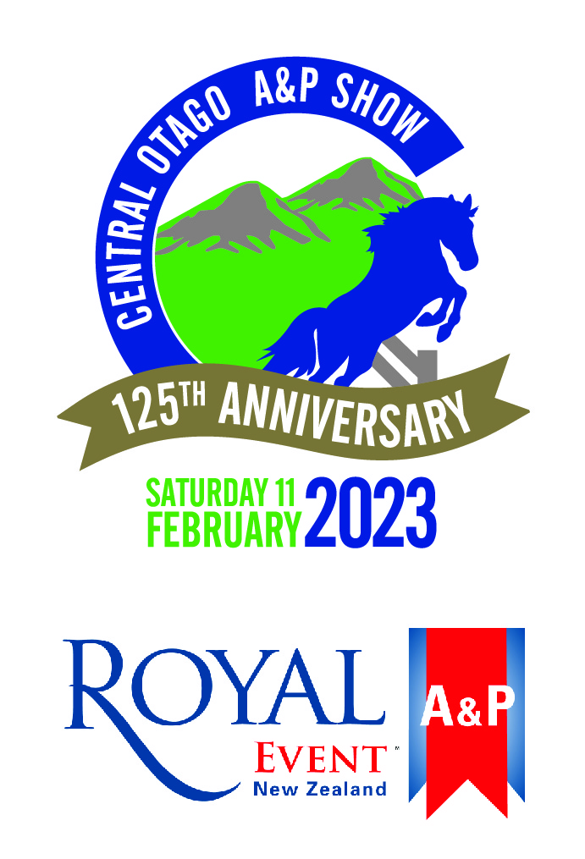
Central Otago A&P Association
Hosting a Royal Event Home Industry Section
125th Annual Show Day
11 February 2023, Omakau Domain

Secretary – Jennifer Huddleston
56 Keddell Rd RD3
Springvale, Alexandra 9393
Ph: 027 229 9213 Email: centralotago.secretary@gmail.com
Find us on Facebook: Central Otago A&P Show
www.coap.co.nz

YES! We wish to sponsor!
Company Name
Contact Name
Email
Mailing Address
Sponsorship Level
Gold ($1000 and above)
Silver ($500 to $999)
Bronze ($250 to $499)
Ruby ($100 to $249)
Schedule Advertising (Printed in September)
Full Page  (Complementary with Gold Sponsorship) | $100
Half Page  (Complementary with Silver Sponsorship) | $50
Please email Advertisement to centralotago.secretary@gmail.com before 10 September 2021
Total Sponsorship:
Additional Information
Trade Site Required (if part of package) |  |  | Yes | No
Ring Side Banners or Advertising will be supplied |  |  | Yes | No
Updated Electronic Logo emailed |  |  | Yes | No
Invoice Required |  |  | Yes | No
Our Account Number is 02-0916-0046025-00

The Central Otago A&P Association thanks you for your support. We would not be able to host the amazing day that we do without you! Thank you!

