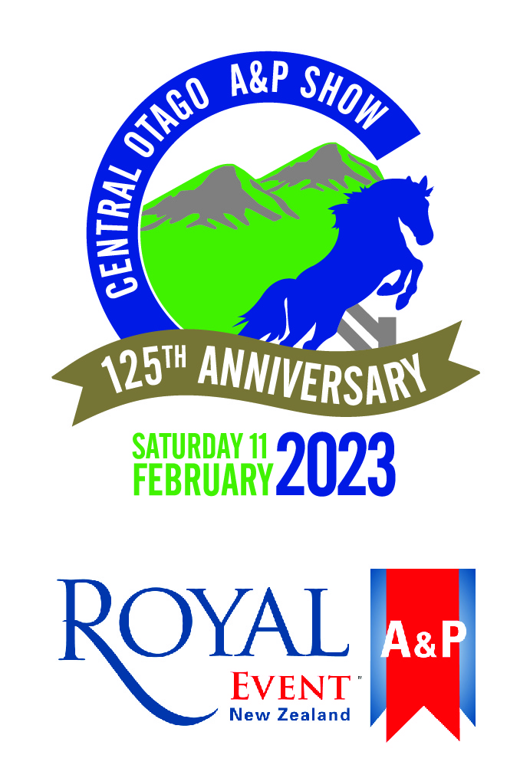
Central Otago A&P Association
Hosting a Royal Event Home Industries Section
125th Annual Show Day
11 February 2023, Omakau Domain

Secretary – Jennifer Huddleston
56 Keddell Rd RD3
Springvale 9393
Ph: 027 229 9213 Email: centralotago.secretary@gmail.com
Find us on Facebook: Central Otago A&P Show
www.coap.co.nz

LIKE TO BECOME A MEMBER??
Have you considered becoming a member of the Central Otago A&P Association?
Being a member helps our committee to meet Show Day expenses.
We hope to continue to grow our Show Day and make it into a ‘must be there’ summer event, especially as we are heading towards our 125th Annual Show Day in 2023. That’s quite a tradition!
By becoming a member of the Association you will be posted a Family Entry Ticket to the Show (to admit two adults and your children under 16 are free) a full schedule of Competition Sections and you will be entitled to reduced entry fees in the Horse, Pony and Sheep Classes.
The annual subscription is $15 per family. (Or Gate entry on Show Day $10/adult)
And just remember all children’s entertainment is FREE on the day.
Please note; Members’ Tickets are personal and not transferable.
Membership funds can be deposited directly to our account, please make your payment clearly identifiable - 02 0916 0046025 00
The committee would also heartily welcome any new comers to our group; even giving a hand for a short time on Show Day would be appreciated.
THANK YOU FOR YOUR CONSIDERATION
Please return this form to 56 Keddell Rd RD3, Springvale 9393 or email to centralotago.secretary@gmail.com ………………………………………………………………………………………………………
Central Otago A&P Association Membership Form – 2022/2023
Name: Subscription:
Postal Address: Email:

